1. Project Name:  
     
   Interactive Newspaper
2. Abstract/Summary:  
     
   The Interactive Newspaper is a light-weight news-retrieving and reading application with the feature to retrieve Local News according to the user’s current location. Unlike apps where the full news article is fully displayed at all times, the Interactive Newspaper shows only a preview description, cutting down data usage and allowing users to quickly scroll through all of the latest news. If the user is interested in a particular news article, they only need to tap once on the article space and the app will instantly open the news article up in the browser of their choice.
3. Progress Report:  
     
   a. Basic Functionality:  
     
   The basic functionality of the Interactive Newspaper has satisfied all of the planned features as described in Milestone 1. There are, however, areas that have changed between Milestones, which are: Horizontal scrolling has now been changed to Vertical scrolling, as this takes less time and feels more natural to do. The other change is the removal of the Table of Contents, which is placed in the main menu activity, where the user can always go back to and press on another section to view instead. This removes clutter that will exist if the table of contents is placed on the same screen as the news section activity.  
     
   b. Standard Functionality:  
     
   The first feature that was to be implemented was the acceleration sensor functionality and the detection of the device being flat on a surface for an extended period of time. If the device was detected to be flat on a surface for a long time, then the app would immediately purge all of the news articles, replacing them with new ones on restart of the activity. Through experimenting with this planned feature, this feature was removed as the feature did not make sense in the scope of the app.   
     
   The sensor functionality is therefore replaced with a light sensor function that detects whether the user is in a low light or bright light environment. Upon detecting that the user is in a low light environment, the app will immediately switch to its dark mode theme, which changes the screen elements (background, text) to alternative colors, placing less strain on the user’s eyes. On the other hand, upon detecting bright light, the app will change back to the light mode theme.  
   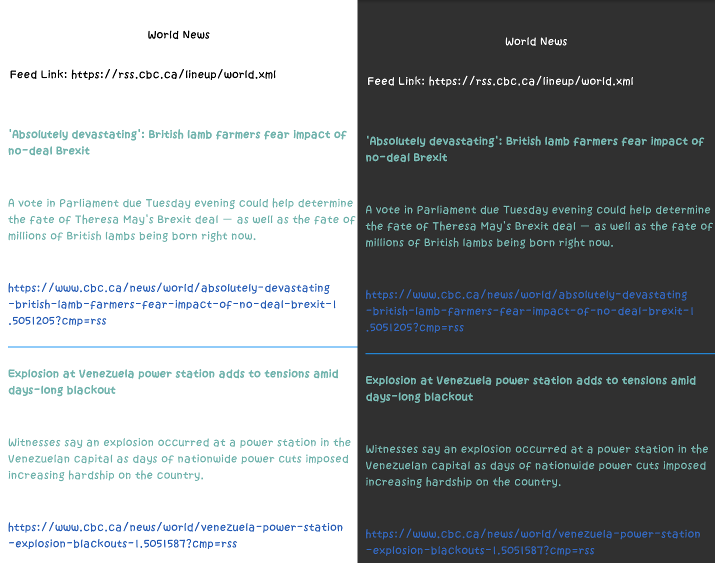  
     
   Location detection through GPS latitude and longitude values are implemented fully into the Interactive Newspaper. This is first done on the main menu activity, which accurately displays the user’s current location, providing their city, province or state and country. Next, if the user is using the app in any Canadian province, the local news section will use the location to display local news corresponding to their location.
4. Common Use Case:  
     
   Users who use the Interactive Newspaper are those who do not have lots of time but want to catch up on the latest news on a light-weight, data-preserving application. The Interactive Newspaper allows for these users to read short descriptions of the latest news, and if the user has time to read an article in full, they can do so by clicking on the card of the selected news article. This then takes the user to the website link, allowing them to read the full news article there. Users might also want to read the news before they sleep. The low light detection functionality helps prevent eye strain when using the Interactive Newspaper in dim or dark environments.